
UNITED INTERNATIONAL UNIVERSITY
Department of Computer Science and Engineering (CSE)
Trimester : Summer 26 (262)
Course Code : CSE 3522
Course Name : Database Management Systems Laboratory
Project Proposal
Submitted By: SQL Syndicate
Student ID | Name
0112420358 | Tahamim Islam
0112420160 | Badhan Roy
0112420176 | Fahad Bhuiyan
0112330513 | Maliha Binte Motin
Submitted To
Faculty Name | Didarul Islam Didar
Designation | Lecturer

“HumanityLink”
A Centralized Web-Based System for Coordinating Charity, Food Donation, Medical Assistance, and Educational Support

Introduction
Many people require assistance with essential needs such as food, healthcare, education, financial support, and basic welfare. However, people who want to help often do not have a centralized platform through which they can identify appropriate charity organizations or report individuals who require assistance. Surplus food from restaurants may be wasted instead of reaching people in need, homeless and vulnerable individuals often go unreported simply because there is no clear channel to report them, and people requiring urgent roadside medical attention may not be connected quickly with an organization capable of helping them.
At the same time, charity organizations largely coordinate their relief, food, healthcare, and educational-assistance activities manually or through social media, which makes it difficult to track welfare cases, verify documentation for educational or financial aid, and maintain transparent donation and transaction records. HumanityLink is proposed to solve these problems by providing a single, centralized web-based system where users, charity organizations, and administrators can coordinate, monitor, and record all such welfare activities in one place.

Objectives
- To develop a centralized platform for coordinating different types of social welfare and charity activities.
- To connect people who need assistance with suitable charity organizations.
- To provide a platform for restaurants and food providers to donate surplus food to people in need.
- To enable individuals to report homeless, abandoned, or vulnerable people who require assistance.
- To provide a system for reporting roadside individuals who require urgent medical assistance.
- To allow charity organizations to organize and manage free healthcare campaigns in different locations.
- To facilitate fundraising campaigns and allow users to contribute donations.
- To maintain transparent records of donations and financial transactions.
- To provide educational financial assistance to deserving individuals based on proper documentation.
- To track the progress and status of welfare cases and charity activities.
- To improve transparency, coordination, and accountability among users, donors, and charity organizations.

Motivation
Our project is motivated by the everyday, visible gaps in how charity work is coordinated around us — surplus food going to waste at restaurants while people nearby go hungry, passers-by who see someone in medical distress on the roadside but have no clear way to get them help quickly, and deserving students who lack a transparent channel to apply for educational assistance. Charity organizations themselves often rely on manual processes or social media posts to manage donations and welfare cases, which limits transparency and makes it hard to track whether a reported case was ever actually resolved. HumanityLink is motivated by the goal of making charitable coordination more organized, transparent, and accountable for everyone involved — donors, volunteers, charity organizations, and the people who need help.

Benchmark Studies
Bangladesh already has a number of well-known charity and welfare organizations that operate largely through their own websites, Facebook pages, or third-party payment apps (such as bKash) for donations. However, none of them provide a single, centralized digital platform that also covers food donation posting, roadside medical/welfare case reporting, healthcare campaign scheduling, and educational assistance verification in one system with case-status tracking. The table below compares key features of HumanityLink with some established Bangladeshi charity organizations.
Feature | As-Sunnah  Foundation | Bidyanondo  Foundation | JAAGO  Foundation | SAJIDA  Foundation | HumanityLink
Online Donation / Fundraising | ✓ | ✓ | ✓ | ✓ | ✓
Centralized Multi-Service Platform | ✗ | ✗ | ✗ | ✗ | ✓
Restaurant Surplus Food Donation Posting | ✗ | ✗ | ✗ | ✗ | ✓
Roadside Medical Emergency Reporting | ✗ | ✗ | ✗ | ✗ | ✓
Homeless / Abandoned Person Reporting | ✗ | ✗ | ✗ | ✗ | ✓
Digital Case Status Tracking | ✗ | ✗ | ✗ | ✗ | ✓
Healthcare Campaign Scheduling System | ✗ | ✗ | ✗ | ✗ | ✓
Educational Assistance Application & Verification | ✗ | ✗ | ✗ | ✗ | ✓
Transparent Donation/Transaction History for Donors | ✗ | ✗ | ✗ | ✗ | ✓
Admin Dashboard for Multi-Organization Monitoring | ✗ | ✗ | ✗ | ✗ | ✓
As the table shows, existing organizations offer strong donation and relief activities individually, but none of them combine food donation, medical/welfare reporting, healthcare campaigns, fundraising, and educational assistance into one centralized, trackable digital platform — which is the core value HumanityLink adds.

Project Overview
HumanityLink is a bridge that connects people who need help with the charity organizations that can provide it. Restaurants/community centers can post surplus food for donation, individuals can report homeless or medically distressed people they encounter, charity organizations can create fundraising and healthcare campaigns, and deserving students can apply for educational financial assistance — all coordinated, tracked, and recorded through one centralized system.
The platform organizes welfare activities into four major areas: Food Support, Medical & Welfare Support, Financial Support, and Education Support, each following a clear, trackable workflow as shown below.
Food Support: Restaurant/Community Center → Food Donation Posted → Charity Organization Claims → Distribution → Completed
Medical / Welfare Support: User Reports Case → Charity Organization Reviews → Case Accepted → Action Taken → Completed
Financial Support: Charity Organization Creates Campaign → User Donates → Transaction Recorded → Donation History Updated
Education Support: Applicant Applies → Documents Submitted → Verification → Approval → Fund Distribution → Record Updated
Users can register, report cases, browse and contribute to campaigns, and view their donation history. Charity organizations can register, receive and act on reported cases, manage food claims, and run fundraising and healthcare campaigns. The administrator verifies organizations and monitors all activity, donations, and cases across the platform, with basic reports and statistics.

Entity-Relationship Diagram (ERD)
The ERD below models the core entities of HumanityLink — User, Charity Organization, Restaurant, Donation, Fundraising Campaign, Support Program, Welfare Case, Food Donation, and Food Claim — along with the relationships that connect them (reports, creates, runs, handles, posts, claims, has, makes, receives).
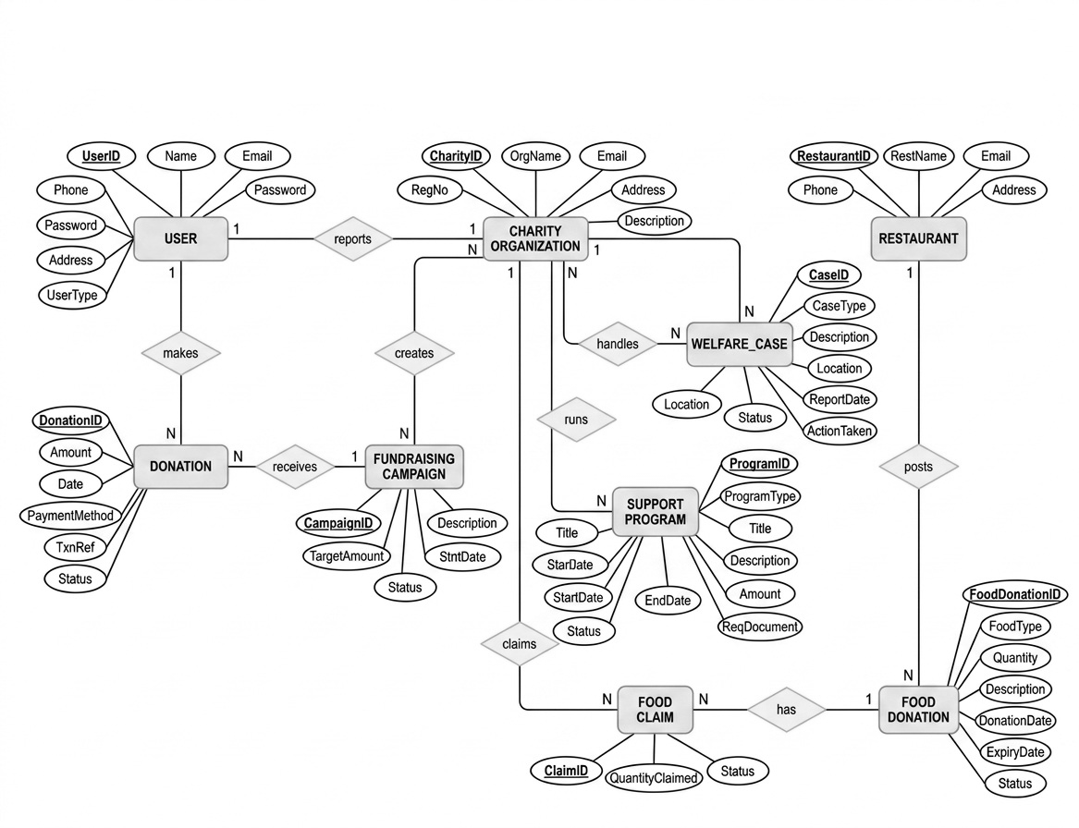
Fig: ERD of HumanityLink

Schema Diagram
The schema diagram below translates the ERD into the relational structure (charity_db) implemented in MySQL, showing tables, primary/foreign keys, data types, and the relationships between user, charity_organization, restaurant, donation, fundraising_campaign, support_program, welfare_case, food_donation, and food_claim.
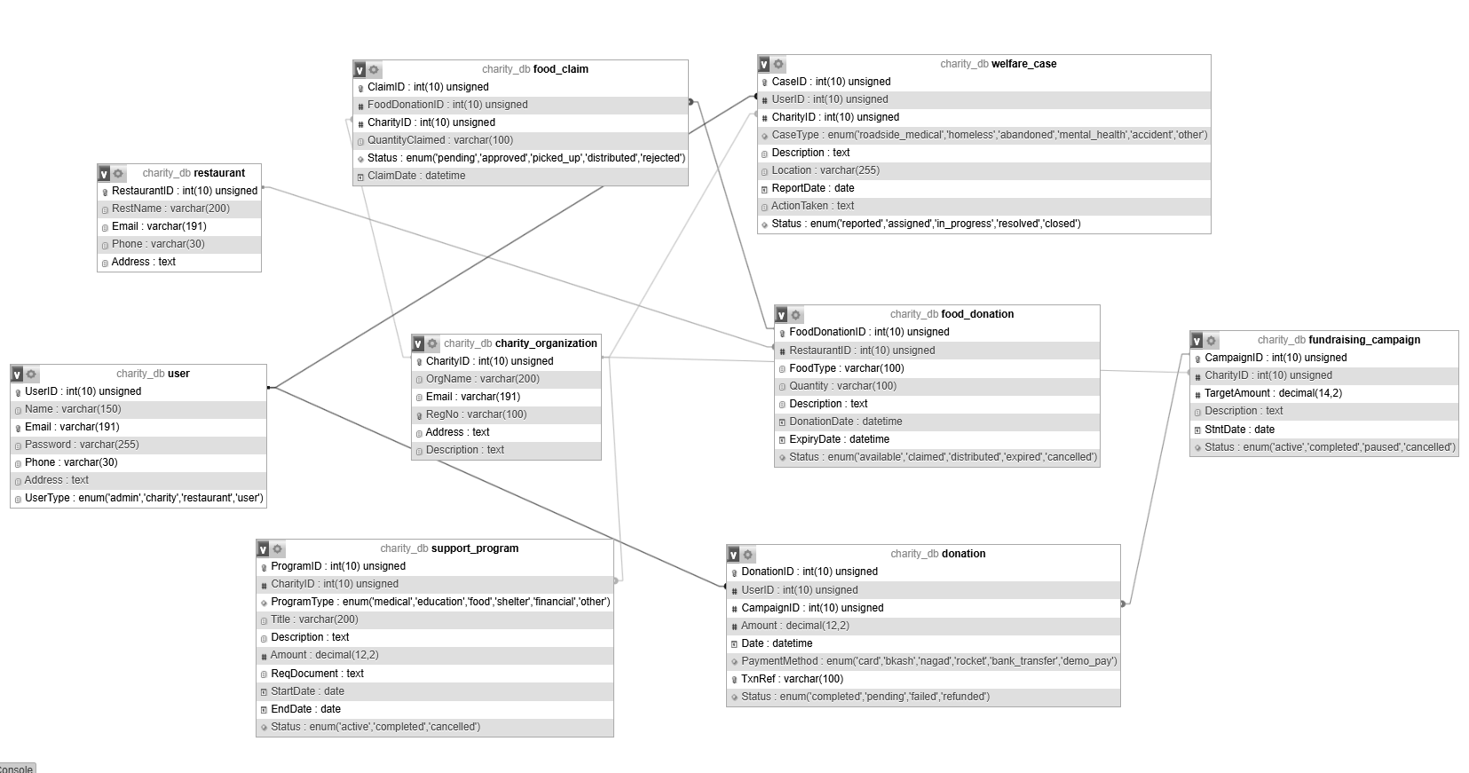
Fig: Schema Diagram of HumanityLink (charity_db)

Technology Stack
Category | Technology
Frontend | HTML5, CSS3, JavaScript
Backend | PHP
Database | MySQL
Server Environment | XAMPP / Apache
Database Management | MySQL, phpMyAdmin
UI/UX Design | Figma
Version Control | Git, GitHub
Other Tools | Visual Studio Code, Font Awesome

Risks and Dependencies
Risks:
- Users may submit false or inaccurate welfare reports.
- Incorrect location information may make it difficult for organizations to locate people requiring assistance.
- Fraudulent fundraising campaigns may be created if proper verification is not implemented.
- Sensitive information about vulnerable individuals may be exposed if security is inadequate.
- Errors in transaction records may affect financial transparency.
- Submitted educational documents may be incomplete or invalid.
- Database failure could result in loss of welfare, transaction, or user records.
- The large number of modules may increase development complexity.
- Limited development time may restrict the implementation of advanced features.
Dependencies:
- Internet connectivity and availability of the web and database server.
- MySQL database availability.
- Participation of charity organizations.
- Accurate information provided by users.
- Availability of healthcare professionals for healthcare campaigns.
- Proper documentation from educational assistance applicants.
- Reliable database backup and maintenance.

Conclusion
HumanityLink is a centralized, database-driven web application designed to connect people who want to help with the charity organizations that can provide that help, while keeping every donation, case, and campaign transparent and trackable. By bringing food support, medical and welfare reporting, healthcare campaigns, fundraising, and educational assistance together in one system, the project aims to improve the coordination, transparency, and accountability of charity-related activities. The project will demonstrate practical application of DBMS, SQL, PHP, MySQL, HTML, CSS, and JavaScript in developing a real-world, database-driven web application.

